SE - Report

Class Participation Report

Name: Rahul Varma

Roll No: S20200010212

The First Thing I want to Mention is “What I have Learnt from this course”:

1. Self-Awareness:

During the class, I gained self-awareness through taking the 16 Personalities Test. It helped me to recognize my introverted nature and fear of public speaking and provided techniques to overcome it. I also learned that introverts have unique strengths, such as listening and reflection, that can be leveraged in the workplace. The class helped me to better understand myself and my abilities, allowing me to identify areas for growth and recognize my unique strengths.

1. Communication Skills:

Class helped me to improve my ability to communicate effectively. I learned about nonverbal communication and how to read and use it, as well as how to communicate in different contexts and handle difficult conversations.

1. Time management: Learned how to prioritize the tasks, manage the time efficiently, and meet deadlines.
2. Teamwork: Learned how to work effectively as part of a team, including how to communicate, collaborate, and resolve conflicts.
3. Workplace etiquette: Learned about workplace norms and expectations, including how to handle conflict, communicate with colleagues, and show respect for others.
4. Social media skills: Learned how to use social media effectively for personal Job interviews and professional networking.

One Speaker Talked about How to use LinkedIn Effectively.

1. Leadership: I learned valuable qualities and skills that are essential for effective leadership. I learned that leadership is not just about giving orders and delegating tasks, but also about inspiring and motivating others to work towards a shared vision or goal.
2. Entrepreneurship: I learned valuable skills and qualities that are essential for starting and running a successful business. I learned that entrepreneurship is not just about having a good idea, but also about being able to turn that idea into a viable and sustainable business.
3. Goal setting: I learned valuable skills and techniques for setting and achieving goals. I learned that setting goals is an essential part of personal and professional growth, and that effective goal setting involves more than just writing down a list of things that I want to achieve.
4. Emotional intelligence: I learned valuable skills and techniques for understanding and managing my own emotions, as well as the emotions of others. I learned that emotional intelligence is a critical skill for personal and professional success, and that it involves more than just being aware of my own emotions.
5. Diversity and inclusion: I learned valuable skills and techniques for creating a more inclusive and welcoming environment. I learned that diversity and inclusion are not just buzzwords, but essential components of a healthy and productive workplace.
6. Professionalism: I learned valuable skills and techniques for presenting myself as a competent and reliable professional. I learned that professionalism is not just about dressing well or speaking formally, but about embodying a set of values and behaviors that are essential for success in any workplace.
7. Problem-solving: I learned valuable skills and techniques for approaching complex problems and finding effective solutions. I learned that problem-solving is not just about being smart or having expertise, but about having a structured and strategic approach to identifying and resolving issues.
8. Interview skills: I learned valuable skills and techniques for preparing for and performing well in job interviews. I learned that the key to a successful interview is not just about having the right qualifications, but also about having the right mindset, communication skills, and preparation.
9. Resume and cover letter writing: I learned valuable skills and techniques for crafting effective resumes and cover letters that showcase my skills and experience. I learned that the key to a successful resume and cover letter is not just about listing my qualifications, but also about presenting my experience and accomplishments in a way that resonates with potential employers.
10. Short Resume Video: I learned valuable skills and techniques for presenting myself effectively in a professional setting. I learned that the key to a successful resume video is not just about listing my qualifications, but also about showcasing my personality and enthusiasm for the job.
11. Group Discussion:

I learned valuable skills and techniques for effective communication and collaboration in a group setting. I learned that the key to a successful group discussion is not just about expressing my own opinions, but also about actively listening to others and building on their ideas.

I wanted to take a moment to express my sincere gratitude for all that you have taught me throughout this semester. Your dedication and passion for teaching have truly made a positive impact on my life and my career goals.

Throughout this course, I have learned valuable skills and techniques for job interviews, life skills, and how to behave and work in companies. Your lessons on self-awareness, communication skills, time management, leadership qualities, entrepreneurship, goal setting, emotional intelligence, diversity and inclusion, professionalism, problem-solving, and interview skills have been valuable to me as I navigate the job market and strive to achieve my career aspirations.

Your commitment to helping students succeed is truly admirable, and I have appreciated your patience, encouragement, and support throughout this journey. Your expertise and guidance have given me the confidence and skills necessary to be successful in my future endeavors.

Once again, thank you for all that you have done for me and for our class. Your impact will be felt for years to come, and I am grateful to have had the opportunity to learn from you.

Class Participation:

Speaker 1:

Question asked by me: Can we ask the interviewer for feedback or ask any questions after the interview is over? If yes, what kind of questions are appropriate to ask?

Reply from the Speaker: (Benjamin)

Yes, it is very important for asking the Questions.

You can ask about the Feedback of Your Interview.

Asking for feedback after an interview can have several advantages, including:

* Insight into your performance: Feedback can provide valuable insight into how you performed during the interview, including your strengths and areas for improvement.
* Clarification on expectations: Feedback can also help clarify any expectations the interviewer has for the role or company culture, giving you a better understanding of what they are looking for in a candidate.
* Identification of areas for improvement: Feedback can help you identify areas where you can improve your interview skills or qualifications, allowing you to adjust for future interviews.
* Demonstrates professionalism: Asking for feedback demonstrates that you are committed to personal growth and improvement and can help build a positive impression of you as a candidate.
* Opportunity to build rapport: Requesting feedback can also provide an opportunity to build rapport with the interviewer, demonstrating that you are engaged and interested in the position.

Overall, seeking feedback can help you better understand how you are perceived by potential employers, and can ultimately help you improve your interview skills and increase your chances of landing a job.

evidence to substantiate.

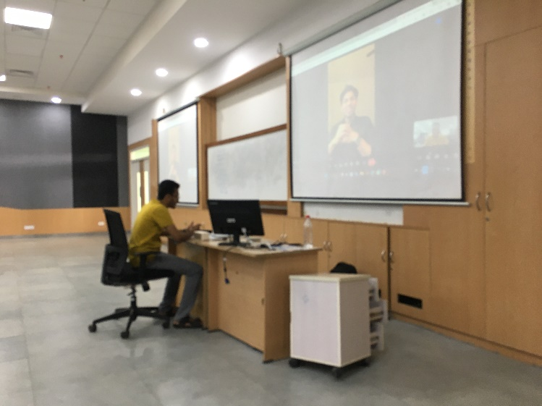

Speaker 2:

Question asked by me:

Is it important that We should be very honesty while including about the experience of internship in the Resume.

As some of our seniors, said we can include some fake experience about internship and manage in the interview.

Speaker Reply: (Raja Raghuram).

Laughs!!!

As a HR, I would strongly advise against including any false or exaggerated information about internship experience on your resume. Fabricating experience may seem like a tempting way to stand out from other candidates, but it can easily be detected during the recruitment process and will likely harm your credibility and chances of being hired. Instead, it's important to be honest and include only your real experiences and accomplishments.

Authenticated by Dasari Kartheek, S20200010055.

Group Activity:

Our department: Board of Governance.

In a group activity, there are 10 different departments of multinational companies in a boat, and due to a problem, the boat is in a dangerous situation with only one rescue boat available. In round 1, participants are asked to justify why their department should be chosen for the rescue operation.

Our Statement for 1st Round:

Board of Governance can be emphasized as it is responsible for the overall functioning and decision-making of the company. The Board of Governance ensures that the company is running smoothly and efficiently, and it plays a crucial role in managing risks and ensuring the safety of the employees. As the boat is in a dangerous situation and the rescue boat is limited, it is important to choose the department that has the most important and critical roles in the company. The Board of Governance is responsible for overseeing all the departments, and therefore it can be argued that their department should be chosen for rescue as their presence is crucial for the company's overall functioning and success. By emphasizing the importance of the Board of Governance, the team can make a strong case for their department's inclusion in the rescue boat.

In round 2, participants must decide which department can be left behind from the other 9 departments.

Our Statement for 2nd Round:

Two HR Teams are there so just simply Leave one HR Team.

Or some Department are ready to sacrifice from the first Round we can just Leave them.

In round 3, participants are asked to provide reasons as to why their department doesn't have a rescue boat and will have to face a fatal outcome.

In the third round,

You trusted us from the starting point of the company start so we believe in You. (By me).

we would like to express our gratitude for the trust and support that our company has shown us since its inception. As employees, we have always worked hard to build the company and make it successful, and we believe that our families' safety is of the utmost importance. Therefore, in the absence of a rescue boat, we would like to sacrifice ourselves for the greater good and ensure that our colleagues and their families are rescued. We trust that the company will continue to thrive and honor our sacrifice.

Round 3: (Statement form me):

Link From Your Drive: (https://drive.google.com/file/d/1K9JQCH3Iv83O-IGTt0_Tc2NGP3wAz68t/view)

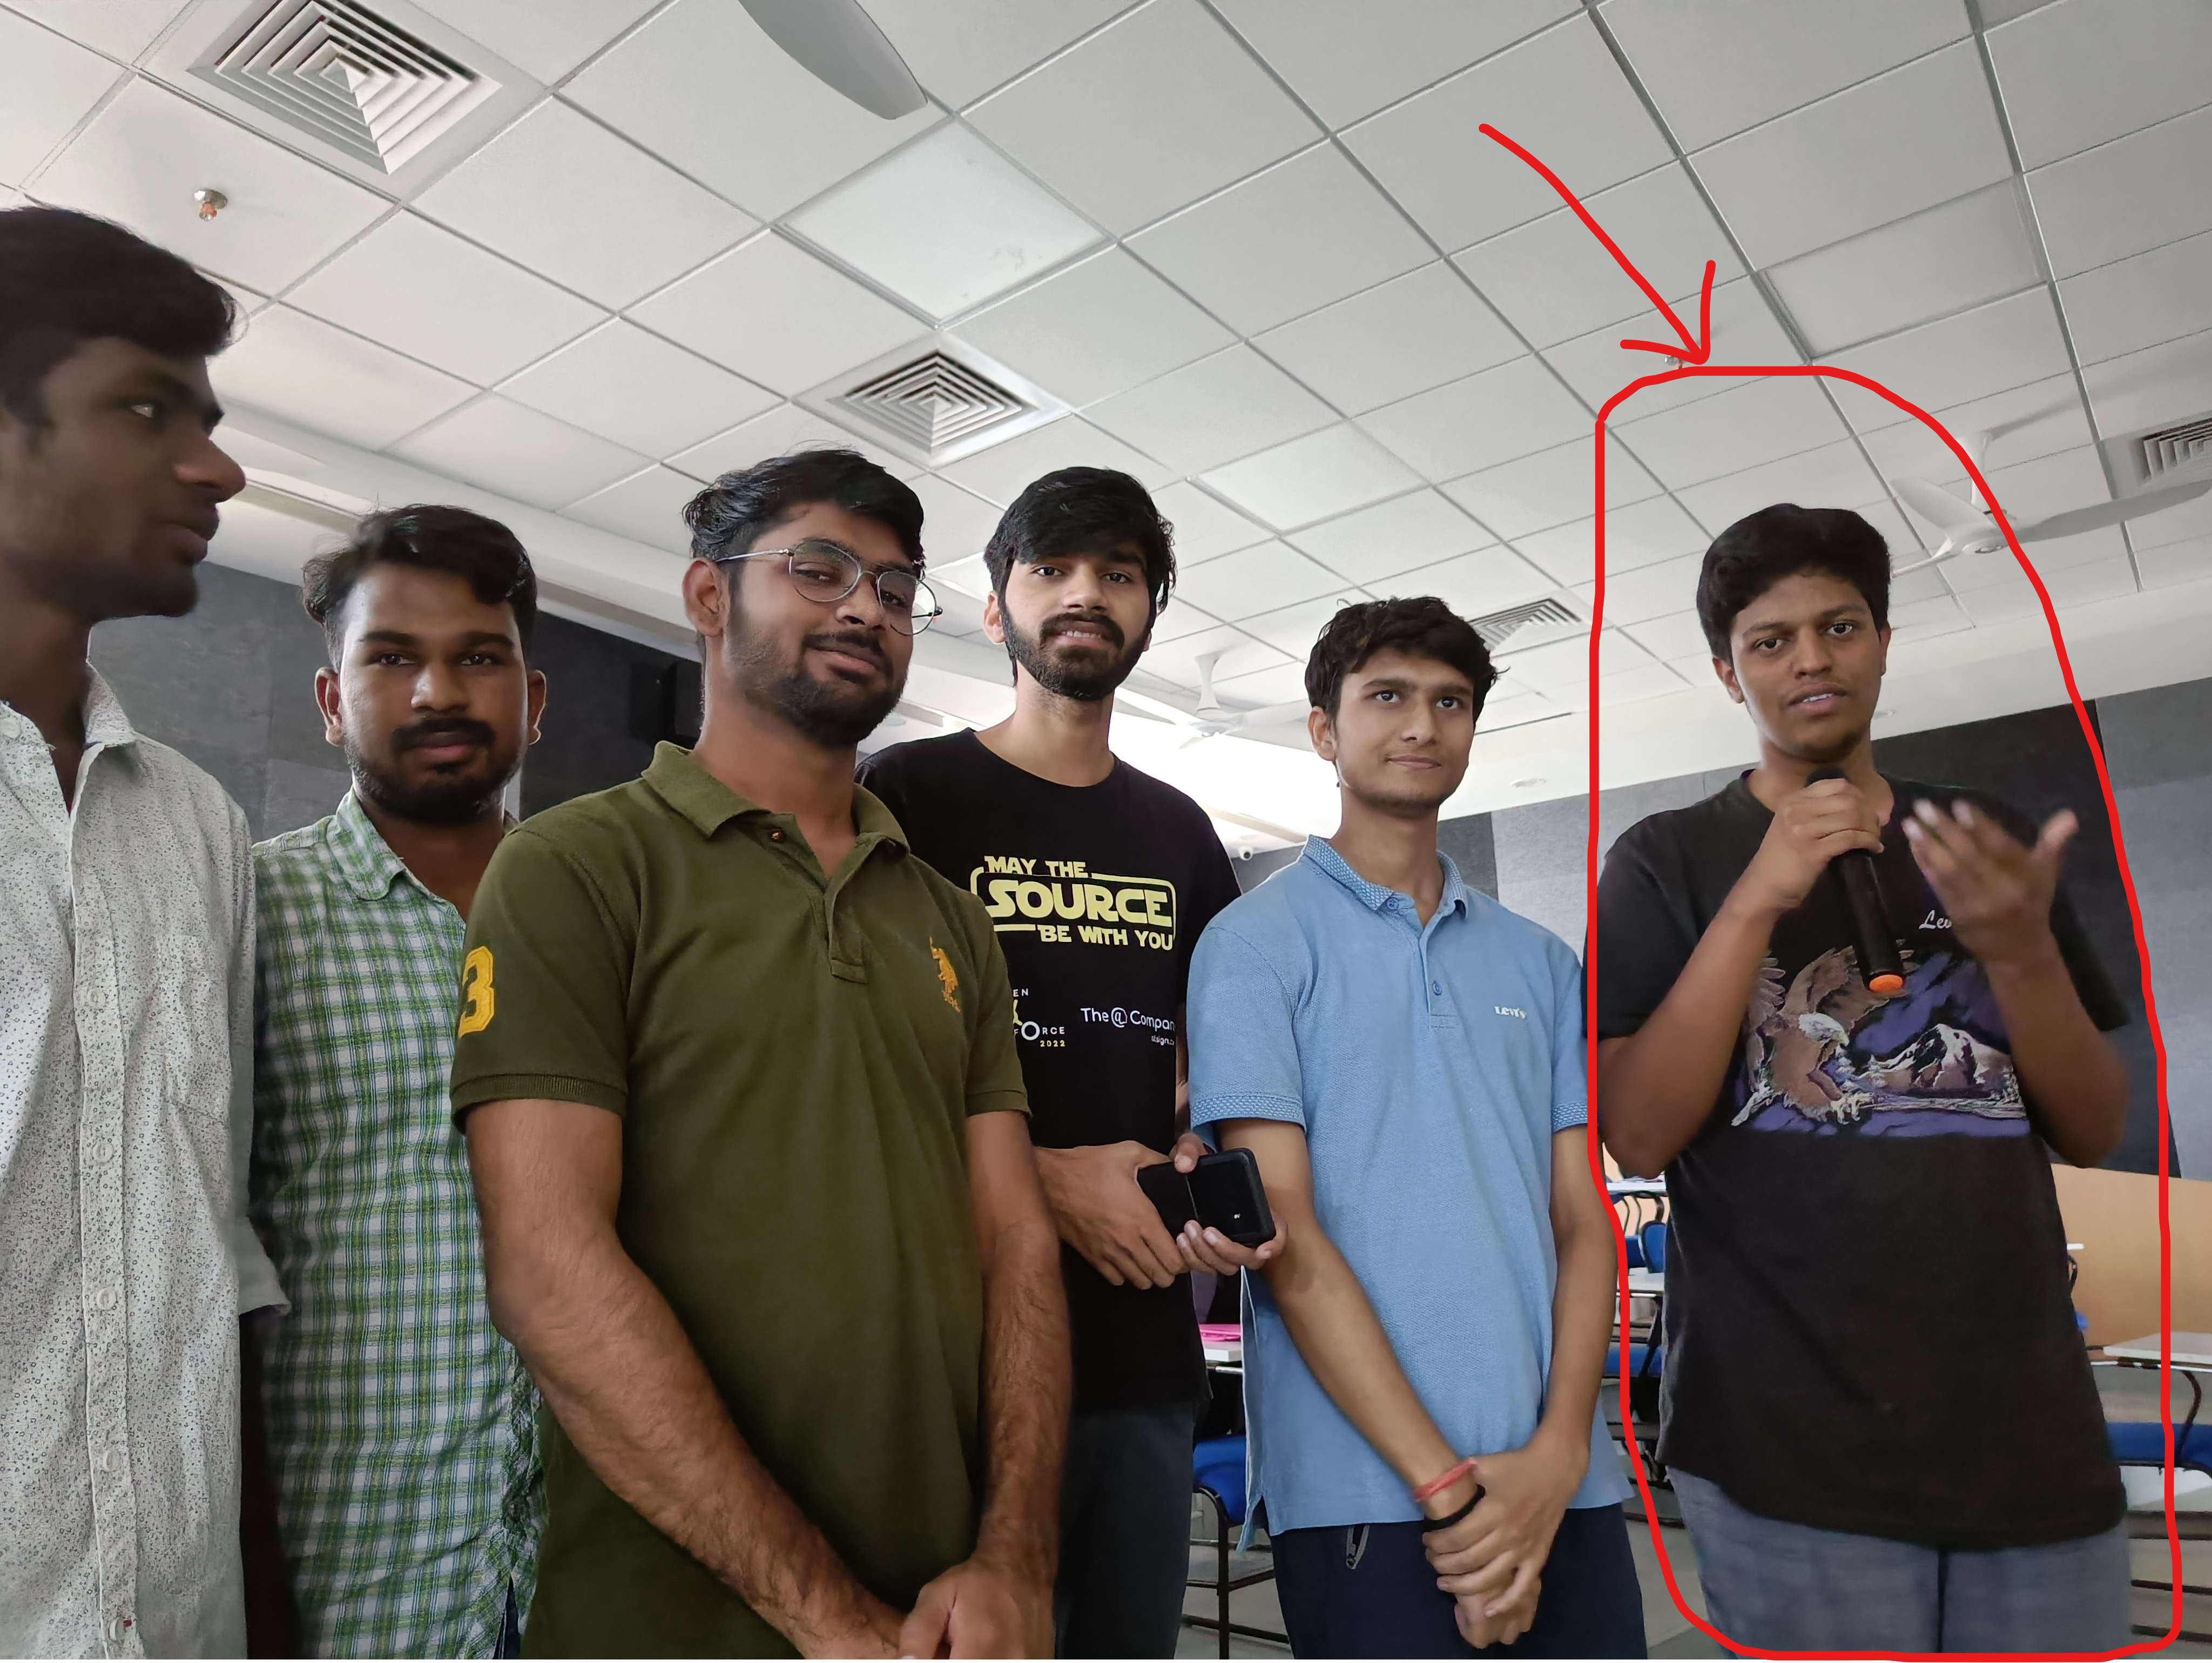

Our Group Task (Boat Task):

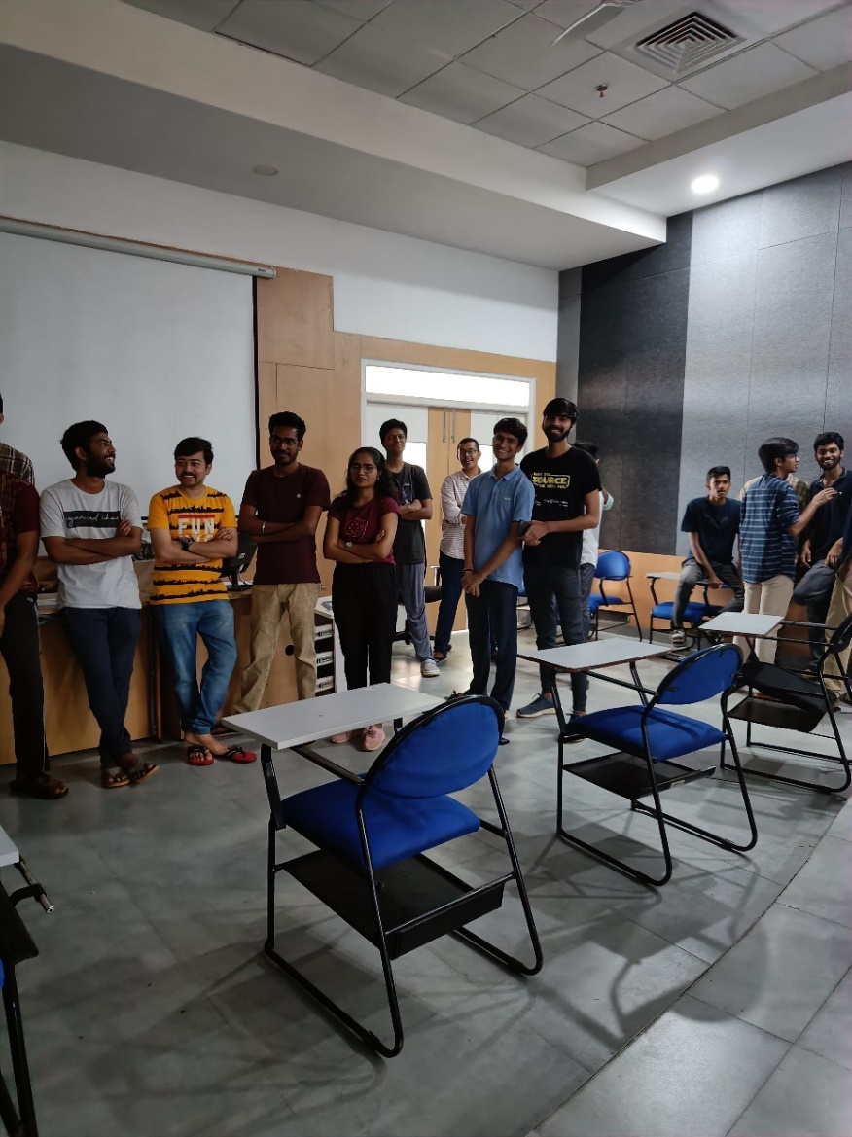 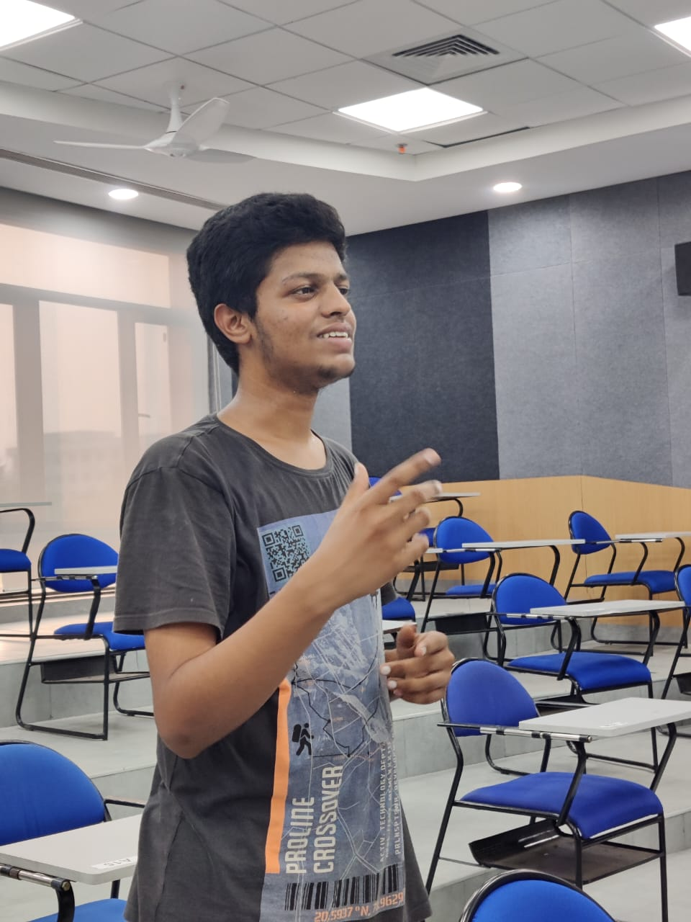

Group Discussion:

Topic: (Hybrid mode vs onsite working)

During our group discussion, we explored the advantages and disadvantages of Hybrid mode and onsite working. We discussed how the Hybrid mode offers flexibility to employees, reduces the cost of office space, and enhances productivity. It also allows organizations to recruit top talent from anywhere in the world, as geographical boundaries are no longer a hindrance. On the other hand, onsite working promotes better communication among employees, enhances collaboration, and enables organizations to maintain a strong company culture.

We concluded that both models have their advantages and disadvantages, and the decision to adopt either model will depend on the organization's needs and the type of work involved. It is crucial for organizations to evaluate their goals and work requirements before deciding which model to adopt. Overall, our discussion provided valuable insights into the benefits and drawbacks of these two models of working.

Proof:

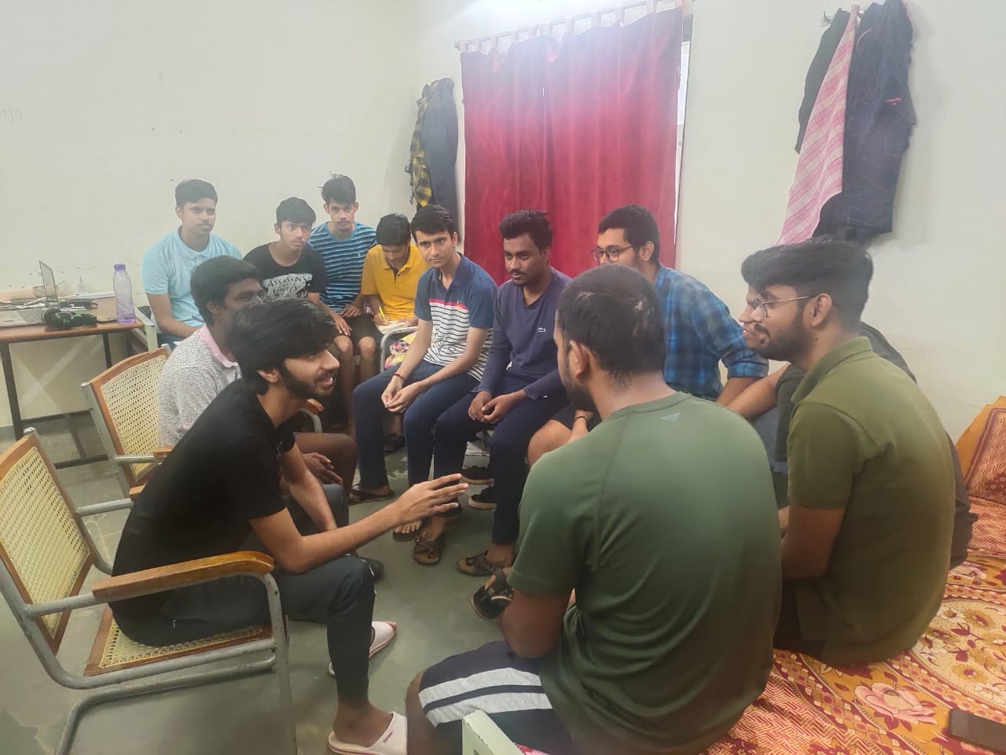

Then We Evaluated Pranay Group: (Proof):

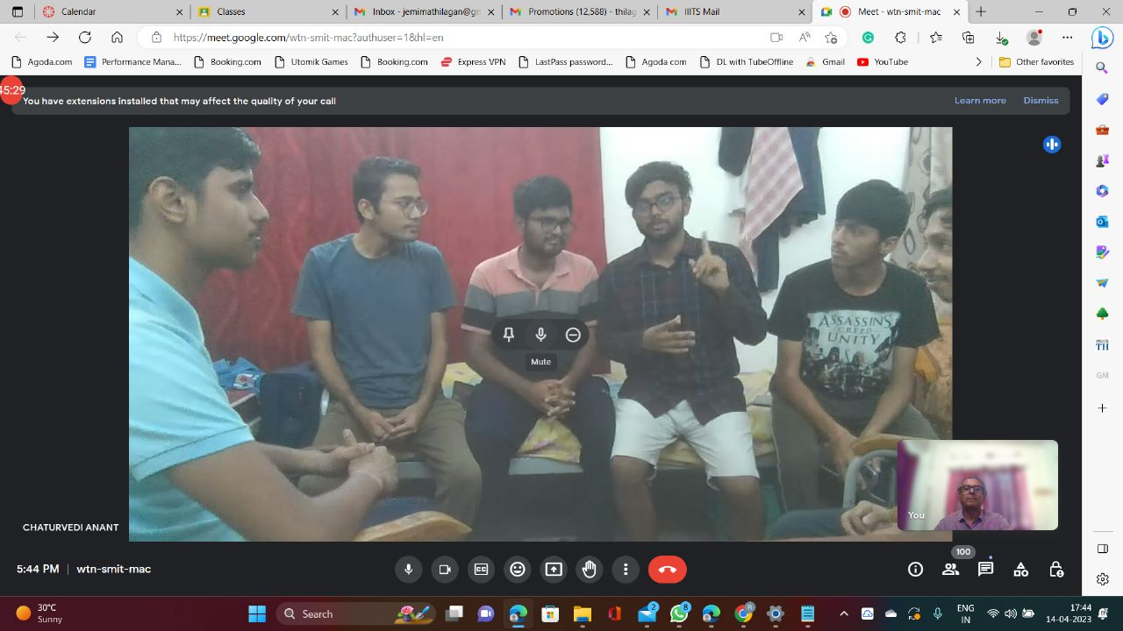

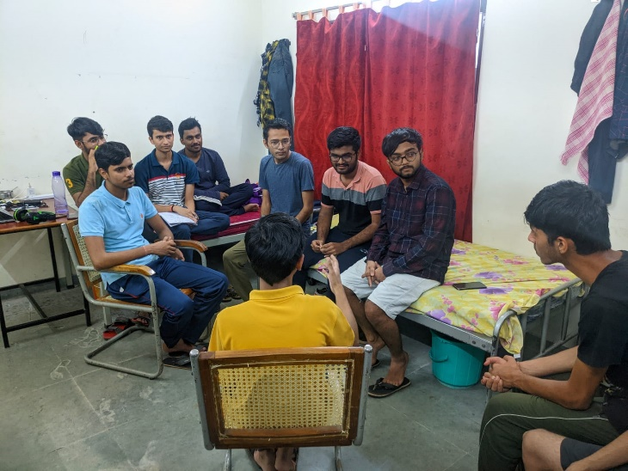

Selected Members:

1. Palle Pranay Reddy – (S20200010159)

2. Siddhart Bharadwaj – (S20200010198)

3. Nitigya Joshi – (S20200010150)

Reason:

They were able to sum up what they were able to say using few sentences. They are more well equipped with the knowledge regarding. the topic and are very actively participating in the discussion. They were also good listeners and waited for the other person to complete their point before coming up with an argument.

Selected Members had Interview in the class.

Authenticated by: (Dasari Kartheek, S20200010055).

During our class, I actively participated in class discussions, group activities, and assignments. I made sure to come prepared to class, asked thoughtful questions, and provided insightful comments during class discussions.

As evidence of my participation, I have attached photos of myself engaging in group discussions, working on assignments with classmates, and participating in class presentations.

One of my classmates, Kartheek has authenticated this report and has confirmed that I actively participated in class and made valuable contributions to group activities and discussions. He accepted all the information included in this report.

Overall, I am grateful for the opportunity to participate in this class and have learned a lot through engaging with my classmates and the course.

